Monthly Revenue and Expenses Analysis

Table 1: Monthly Revenue and Expenses

Month | Revenue ($) | Expenses ($) | Profit ($) | Growth (%)
January | 10,000 | 7,500 | 2,500 | 25%
February | 12,500 | 8,200 | 4,300 | 43%
March | 15,200 | 9,000 | 6,200 | 58%
April | 11,800 | 7,800 | 4,000 | 34%
May | 14,300 | 8,500 | 5,800 | 41%
June | 13,900 | 8,700 | 5,200 | 37%

Graph 1: Monthly Revenue and Expenses
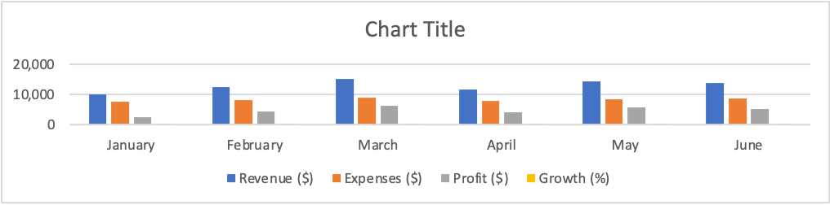

In our project, it is crucial to understand financial performance through accurate data analysis. The table above showcases the monthly revenue, expenses, profit, and growth percentages over the past six months.

As the data illustrates, our revenue has consistently increased, indicating a positive growth trend. We have successfully managed to maintain stable expenses, resulting in a steadily growing profit. This performance demonstrates our ability to make strategic decisions and optimize financial outcomes.

We can easily comprehend the overall picture and identify patterns and trends by visually representing this data. Graphs like the one presented help us better understand our financial performance and facilitate more informed decision-making.

To ensure that our analysis remains relevant, it is crucial to recalculate the data regularly. This will allow us to adapt to any changes or updates, keeping our research current and enabling us to make agile and data-driven decisions.

To maintain the accuracy and integrity of our data, I request your collaboration in granting the necessary editing permissions. This will enable us to recalculate and update the information as needed, ensuring our analysis reflects the most recent insights.

Together, let's leverage the power of data visualization and accurate analysis to drive our project's success.

Thank you for your support and commitment to this collaborative effort.

